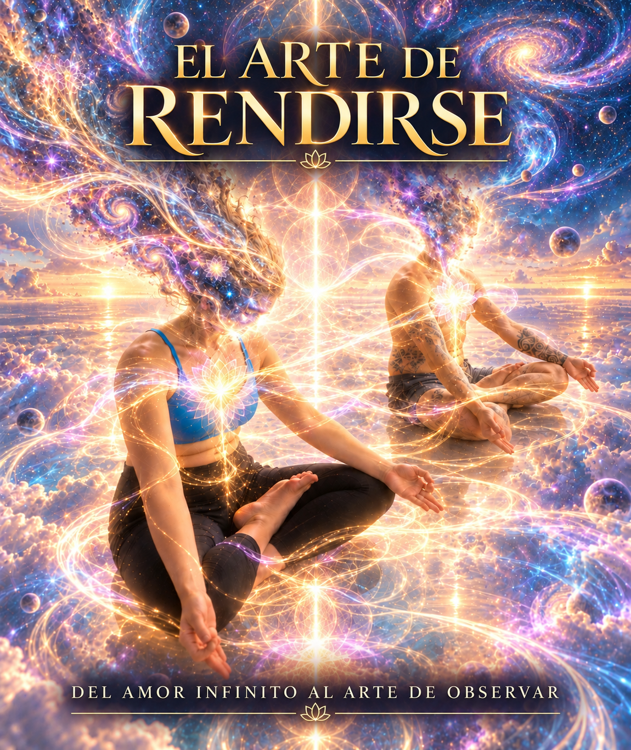
THE ART OF SURRENDER
From Infinite Love to the Art of Observing

The first revelation did not arrive as an explanation. It arrived as love.
Before infinite universes, dimensions, the empty cup, the garden, mirrors, or observation existed in my language, an extraordinarily simple phrase appeared:
“You and I are us.”
I entered that first experience without knowing that those words would become a question whose meaning would change many times. At that moment, I believed I had found an answer. With time, I would understand that I had only found the first door.
Love appeared as something immense and physical, impossible to contain within the ordinary limits of an emotion. It did not seem to be merely something I felt for another person. It moved through my body. It ran through every cell and, at the same time, seemed to extend far beyond me.
“You and I are us, and I am you, and we are nothing and everything.”
Those words already contained, in a still intuitive way, almost everything I would later try to understand.
I.
You.
Us.
Nothing.
Everything.
They were still separate concepts, spoken by a mind trying to describe an experience that seemed to have erased the very boundaries between them.
And then the child appeared.
A playful, mischievous child, full of love and laughter. I recognized him as myself, and yet I could look at him as though I were meeting someone for the first time.
“You are very beautiful.”
“I love you very much.”
There were hugs. Kisses. Laughter.
Perhaps one of the first truly profound movements of this entire journey happened there, although it would take me a long time to understand it. Before learning to love the universe, before imagining infinite dimensions, before asking what the ego was or who the observer might be, I had to meet that child and tell him something he apparently needed to hear:
I love you very much.
The search began by looking toward something immense, but from the beginning there was a small sign telling me that one day I would have to return inward.
And alongside love, another word appeared.
Surrender.
At first, surrender seemed simple. Let go and allow that extraordinary current to move through me. When I stopped resisting, light, beauty, and love appeared.
“Surrender; there comes true love and the most beautiful light I have ever felt.”
It seemed like a formula.
Resistance meant separation.
Surrender meant love.
But I still did not know how much could be hidden inside a single word.
Because even after discovering surrender, there was still someone inside me who wanted to possess that to which he claimed to have surrendered.
I wanted to preserve love.
I wanted to preserve the people I loved.
I wanted to protect my daughters.
I wanted to hold on to Elena.
I even wanted to hold on to those extraordinary experiences and return to them.
The ego could pronounce the word surrender while keeping its hands tightly closed.
It would take me much longer to see that.
At first, everything was expansion.
The experiences that followed seemed to open an ever-larger reality. Communication no longer necessarily required words. I began to experience the possibility of listening in another way.
“Communicate without words. Do not even repeat them in your head.”
Listen.
Be quiet.
Observe.
These words began to appear again and again.
In one of those experiences, I received a warning that was almost comical in its simplicity:
“You are too noisy.”
Be quiet.
Listen.
You do not need to explain everything.
You do not need to intervene in everything.
“By listening quietly, you are going to receive more information from now on.”
At the time, it seemed like a small teaching compared with the enormity of what I was experiencing. Much later, I would understand that it was one of the most important instructions of the entire journey.
For a long time, I confused understanding with intervening.
If I saw something, I wanted to interpret it.
If I understood something, I wanted to explain it.
If I loved someone, I wanted to help them.
And if I believed I knew something that might benefit another person, I felt the impulse to show it to them.
I did not yet understand that even help can become a form of possession.
My love for Elena occupied a central place in those early experiences.
Her music could become light inside me. The vibrations of her singing bowls seemed to transform into endless waterfalls of color, tenderness, and beauty.
“Elena is pure light and love.”
The boundary between person, sound, and feeling disappeared. At times our heads seemed to meet within rivers of color. At others, her face moved through people, animals, and forms. There was even the feeling that we had met in a place where bodies no longer mattered, laughing and loving one another with our souls.
It was beautiful.
But hidden inside that beauty was a contradiction.
I spoke of unity while I still wanted to possess.
Until a much more painful understanding appeared:
“They are not mine.”
My daughters were not mine.
Elena was not mine.
“They belong to the universe. They are free, and they will go.”
That changed the meaning of love.
To love could no longer mean holding tighter.
Perhaps loving meant precisely opening the hand.
I had given hugs, kisses, protection, warmth, and tenderness. I had also caused pain through my immaturity and frustration.
Both things could be true.
I could have loved deeply and still have hurt people.
Accepting one did not erase the other.
Slowly, an idea appeared that would become fundamental: loving someone did not give me ownership of their path.
Then another trap appeared.
Spirituality itself.
“How do I get to the next level?”
The question seemed reasonable.
If I had discovered something extraordinary, there had to be another level. And then another.
More depth.
More knowledge.
More purity.
More consciousness.
Until the answer came:
There is no next level.
Or at least, not in the way I had imagined it.
The obsession with ascending could feed exactly what I was trying to free myself from.
If I was higher, then someone else necessarily had to be lower.
And there was the ego again, now dressed in spirituality.
“That way of thinking inflates my ego, making me think I am better than others.”
The paradox was brutal.
I could try to transcend the ego by using the ego.
I could become proud of my humility.
I could feel superior because I had discovered that no one was superior.
Then another teaching appeared:
“You have to love them all, with their faults, their sins, and their imperfections.”
The spiritual ladder began to come apart.
As that happened, my vision of the universe became increasingly vast.
I began to experience universes as infinite, contained within one another. Time stopped seeming linear. My ancestors appeared as a continuation of the same energy. Every decision could be imagined as a branching point capable of generating another reality.
Every breath.
Every word.
Every movement.
“I am a generator of universes.”
For a while, that idea produced an enormous sense of creative power.
But slowly it stopped being about the ability to create universes and became a much closer question:
What kind of world am I creating for the people around me?
Within the same reality, I could be kind to one person and an executioner to another.
I could be a lover and a source of suffering.
And I wrote:
“It would be good to be only the lover, full of kindness. Try to be that.”
The infinite universes began to return me to my own words.
To my actions.
To the way I treated others.
Cosmology was slowly becoming responsibility.
And surrender returned.
But this time it no longer meant simply letting myself be carried by an experience.
“SURRENDER IS DEEPER THAN I THOUGHT.”
There were levels of surrender within levels of surrender.
Then I discovered an extraordinarily subtle trap.
I could also surrender in order to obtain something.
I could think: I am going to surrender because I know love comes afterward.
But that was not surrender.
It was negotiation.
I gave up resistance expecting ecstasy in return.
I had turned even surrender into a transaction.
“Do not seek love through surrender. Surrender first, and love appears instantly.”
The difference seemed small in words and enormous in meaning.
I could not surrender in order to obtain love.
I had to surrender without knowing what would come next.
In other experiences, that expansion reached extremes that were difficult to describe.
“Love killed me. Destroyed and regenerated.”
There were no questions.
There was no distance.
There was no time.
I felt entire universes moving through body and soul simultaneously. The intensity seemed to exceed any ordinary capacity to contain it.
And yet, after all that immensity, an almost comically simple teaching appeared:
“Why do you complicate yourself so much?”
All happiness was right there.
In front of me.
“Love yourself a lot. I love you very much. And the universe adores you.”
After so many dimensions, universes, symbolic deaths, and experiences of infinity, I returned once again to that child.
I love you very much.
Perhaps I had not advanced as far as I imagined.
Or perhaps advancing meant returning to the same place and understanding it differently.
Surrender then stopped being merely a beautiful idea.
It became confrontation.
There were intense experiences, excessive and at times unbearable. There was love, fear, purging, loss of the ordinary sense of time, laughter, tears, humility, and the feeling that I had received far more than I could contain.
But within all that enormity, a fundamental phrase appeared:
“No more self-destructive behavior.”
Suddenly, surrendering to the universe did not mean disappearing.
It meant caring for this life.
There was a difference between surrendering the ego and destroying the body.
Between accepting death as part of existence and wanting to abandon life.
Between letting go and abandoning myself.
In one of the most extreme moments, I felt prepared to die, but I understood that this was not what was being asked of me.
“It was more surrender and understanding.”
Life was still there.
And it had to be lived.
Another ceremony carried this teaching even further.
I entered wanting once again to reach the world of the Great Spirit.
I forced it.
And the more I tried to force the experience, the more uncomfortable it became.
Unpleasant images appeared. I tried to avoid them. They returned.
Then an immense sadness arrived.
I cried like a child.
But something happened that I had never considered: if love could feel infinite, why could sadness not be infinite too?
I experienced what I described as an:
“Orgasm of sadness.”
The phrase was contradictory and, precisely for that reason, exact.
I understood that I could not accept only the emotions I called spiritual, beautiful, or luminous.
Sadness also belonged to the whole.
Then peace arrived.
And all that metaphysical searching was suddenly brought down to something brutally concrete:
Do you want to sustain this peace in your life?
Then live.
Honestly.
“Do the right thing when no one is watching.”
That phrase cut through years of philosophy.
What did it matter to speak about infinite love if I then lied to myself?
What did enlightenment mean if I continued acting against what I already knew was right?
What value was there in experiencing the unity of all beings if I used that experience to feel superior?
“You are not Jesus or Gandhi. Do not think you are all-powerful and enlightened.”
I needed to hear that.
Spirituality could not become another mask.
There were later moments of exhaustion.
Moments when I thought perhaps I had experienced enough of this world.
“There is so much suffering here.”
But even within those thoughts, the bond with the people I loved appeared immediately.
My daughters.
Elena.
My family.
The question stopped being what might exist beyond this life.
The question became how to live here.
And little by little, a different answer emerged.
I did not need to punish myself.
I did not need to turn every lesson into suffering.
“Do not turn it into suffering. It is for learning, growing, and laughing.”
That marked another change.
For a long time, I had associated depth with intensity.
Perhaps I had also associated learning with pain.
But why?
Why did a teaching have to destroy me in order to be true?
Why could I not learn beautifully?
“With gentleness. I love you.”
Then the garden appeared.
After so many cosmic images, a simple metaphor began to organize everything.
Take care of my garden.
Do not live in the past.
Do not spend all my energy trying to control what will grow tomorrow.
Prepare the soil.
Water it.
Fertilize it.
Turn the earth.
Care for it with affection.
And then wait.
“No flowers, no fruit.”
Do not care for the garden while demanding a reward.
Care for it because caring for it is already the practice.
When the seeds arrive, they will arrive.
When it blooms, it will bloom.
That was surrender transformed into daily life.
Prayer changed too.
It was no longer simply asking for something.
I could pray from my small corner.
For my daughters.
For Elena.
For my parents.
For strangers.
For the planet.
For the sun.
For the moon.
For what I would never know.
But even there, the danger of feeling special remained.
If I imagined that my prayer illuminated the universe, I had to remember the other teaching at the same time:
Humility.
Spiritual experience could open me.
But it could also inflate me.
So the task remained the same.
Listen.
Quietly.
With time, one of the most important transformations of the entire journey appeared.
For a long time, I had felt that the extraordinary beauty of the ceremonies came from somewhere outside me.
From spirit.
From the universe.
From the divine.
Then another possibility appeared:
“The beauty I felt and lived in ceremonies is the beauty inside me.”
That changed everything.
From the first experience, I had imagined the divine as a separate entity.
Something toward which I could travel.
Something I could find.
Something that could receive me.
Now I wrote:
“From the first ceremony I thought the divine was a separate entity. And it has always been me.”
But that did not mean my individual personality was all-powerful.
The understanding seemed to move in precisely the opposite direction.
What I called I was becoming less solid.
If we were all one, expanding my capacity to love was not a private achievement.
Others were:
“My little mirrors.”
Each person could show me a part of myself.
Some reflected dark places.
Others showed me my capacity to love.
Elena had been one of those mirrors from the beginning.
Perhaps that was why my love for her had occupied such a profound place throughout this process.
But a mirror does not belong to me.
And I do not belong to the mirror.
We meet.
We reflect one another.
We learn.
And we continue.
Little by little, the word love acquired a new structure.
Until then, it had been unity, ecstasy, energy, universe, surrender.
Now three much more human words appeared:
Affection. Acceptance. Compassion.
Especially compassion.
Compassion toward others, yes.
But first toward myself.
Accepting my faults and my virtues.
Accepting that I do not know.
“I do not know very much. Forgive me, I do not understand.”
At the beginning of the journey, that might have felt almost like defeat.
Now it began to feel like wisdom.
Not knowing could be a form of openness.
Respect also became clearer.
Do not intrude into the ceremonies of others.
Do not try to save them.
Do not alter their paths.
On one occasion someone told me:
“You saved me.”
But I understood that I had not tried to save anyone.
I had been occupied with my own process.
And perhaps precisely because of that, something in my presence had touched another person.
“Love expands all by itself.”
It did not have to be pushed.
It did not have to be imposed.
It did not have to convince.
That represented a profound transformation from the man who wanted to help, correct, protect, and direct.
Helping could begin by looking inward.
If I recognized a wound in another person, I could look for the reflection of that wound within myself.
And work there.
“When I heal myself, I help heal everyone else.”
Whatever metaphysical meaning I might give that sentence, it contained a concrete discipline:
Before trying to fix another person, observe myself.
Then a spider arrived.
In a dream it appeared large, dark, and threatening.
At first it was simply there.
It moved through its web.
I grabbed poison.
I attacked it.
And then it attacked me.
When I woke, I asked to understand.
The interpretation came almost immediately:
While I observed, nothing happened.
When I attacked, I was attacked.
Observe.
Listen.
Be quiet.
The same words returned.
But they no longer meant only receiving spiritual information.
Now they described a way of relating to life.
Reconciliation with my father deepened that movement even further.
I had to face the pain of how I had spoken to him and everything that had happened between us.
I cried.
I tried to forgive myself.
And within the experience, my grandparents appeared as figures of wisdom, accompanying me toward a different interpretation of an old wound.
My father's abandonment, which for so long could be felt only as absence and pain, began to be seen through another possibility: perhaps that had been all the love he was capable of giving at that moment.
I did not need to turn abandonment into something good in order to recognize that a person can love from within their own limitations.
And then I could look at my own history differently.
I too had made painful decisions believing they were the only way to end greater suffering.
Condemnation began to become understanding.
And understanding became compassion.
Not to erase responsibility.
But to stop turning it into a life sentence.
Then another, even more difficult question appeared.
What was I to do with the constant inner conversation?
Judgment.
Classification.
Projection.
Was I supposed to eliminate all of it?
Or embrace it too as part of myself?
For decades, I had known how to punish myself.
Even my body could reproduce that logic: pushing too hard, tightening, forcing, trying to understand through suffering.
Then another phrase appeared:
“There is no need to punish myself anymore.”
The preparation had already been done.
Perhaps there had even been too much of it.
Now it was time to learn in another way.
“Let life teach you beautifully.”
And then came the empty cup.
At first I thought I had to empty it of sadness and fill it with happiness.
But another understanding appeared immediately.
I was both.
Happiness and sadness.
Full and empty.
Then:
“There is no cup.”
There was nothing to fill.
Nothing to empty.
“I am everything and I am nothing at the same time. I am the emptiness.”
The task was no longer to manufacture the perfect state.
It was to observe the movie.
To see.
To learn.
To recognize the place from which I was watching it.
The search was beginning to change radically.
For a long time, I had asked:
How do I get there?
Now the question was becoming:
Can I simply see?
Then another uncomfortable question appeared.
How many layers had to be removed?
There could always be another one.
Another wound.
Another imperfection.
Another layer of ego.
Another form of purity.
Another revelation.
If the process was infinite, when would I have permission to be okay?
The answer began to emerge:
Now.
“Accepting myself as I am now is the only thing I can do right now.”
Perhaps absolute purity was another version of the next level.
Another ladder.
Another promise that finally, after the next piece of work, the next ceremony, the next understanding, I would earn the right to rest.
But what if I did not have to wait?
Gratitude then acquired another meaning.
It was not merely repeating thank you.
It was recognizing deeply:
I already have everything I need.
And when that became real, the need to chase diminished.
More things.
More experiences.
More knowledge.
More recognition.
Even more spirituality.
And finally, the question hidden inside that first phrase appeared:
“You and I are us.”
But who is I?
If my thoughts appear and disappear, are they me?
If my body changes, is it me?
If my emotions change, are they me?
If what I call identity can be observed, then:
Who is observing?
“If I do not exist, then who is meditating here? Who is thinking here? Who is conscious here, trying to observe himself?”
For the first time, the search reached a place where no quick answer seemed sufficient.
Even saying:
“I am the divine spirit”
could become another identity to which I might cling.
Perhaps that statement also had to be observed.
Perhaps even I am the universe eventually had to be released.
Then a word that had been present from very early on acquired a new depth:
Observation.
I began to understand the relationship among respect, compassion, and observation.
To be able to look at each person on their path without intervening.
To find beauty without possessing it.
To recognize mistakes without turning them into condemnation.
And a powerful image appeared: a dark layer covering the light, opening and closing.
I interpreted it as ego.
Before, I would have wanted to tear it away completely.
Now a different understanding appeared.
Perhaps the ego also had infinite layers.
Perhaps eliminating it completely was another impossible task.
And then something emerged that would have been difficult to accept at the beginning:
I do not have to be perfectly pure.
I will make mistakes.
I will judge.
I will react.
I will fall again into old patterns.
And when that happens, compassion can exist there too.
I do not need to suffer because of my ignorance.
I can see it.
Learn.
And continue.
Then another word arrived:
Moderation.
More did not necessarily mean deeper anymore.
More intensity could prevent me from experiencing.
More knowledge could become a labyrinth.
More searching could feed the very thirst I was trying to quench.
And then a sentence appeared that was extraordinarily different from the period when I had felt tired and wanted to return to the divine:
“I want to live.”
I want to live.
I want to experience this existence.
“It is a privilege to be here, and I am going to enjoy it as much as I can.”
Perhaps this was one of the most important transformations of the entire journey.
The divine was no longer in opposition to this life.
I did not have to leave this world to find it.
If what I called divine was also here, then living fully could itself be part of surrender.
Finally, observation stopped being a concept.
I sat.
I listened.
I looked.
I was quiet.
I tried to respect the experiences of those around me.
And for moments, I stopped waiting for what came next.
Not the next song.
Not the next vision.
Not the next revelation.
Not the future.
Not the past either.
Only what was happening.
And I understood something extraordinarily simple:
Much of suffering appeared when I left the present.
When I demanded something from the future.
When I remained attached to the past.
Observation did not mean indifference.
It was presence.
Undivided attention.
And there returned the teaching that had appeared almost from the beginning:
Listen. Observe. Quietly.
I had traveled through infinite universes to return to three words.
When I look at the entire path now, I see that every certainty opened another question.
First I thought I had discovered love.
Then I discovered that I could try to possess it.
I learned to surrender.
Then I discovered that I could use surrender to obtain a reward.
I sought to elevate myself spiritually.
Then I discovered that I could use spirituality to feel superior.
I wanted to help.
Then I understood that help without respect could become interference.
I sought purity.
Then I understood that the obsessive search for purity could become another form of rejecting myself.
I wanted to destroy the ego.
Then I discovered that even wanting to destroy it could be another expression of ego.
I searched for the divine outside myself.
Then I recognized it within.
And finally I had to ask what it even meant to say:
“myself.”
Perhaps that is why the first phrase remains alive.
You and I are us.
At first it meant fusion.
Then it meant love.
Then unity.
Then letting go.
Then responsibility.
Then mirror.
Then respect.
And now perhaps it means something even simpler.
I do not need to possess you in order to love you.
I do not need to change you in order to walk beside you.
I do not need to understand you completely in order to respect you.
I do not need to save you.
And I do not need you to save me.
I can tend my garden.
You can tend yours.
We can meet.
We can reflect one another.
We can love one another.
And when fear appears, observe it.
When ego appears, observe it.
When sadness appears, observe it.
When love appears, do not grasp it.
When beauty arrives, receive it.
When I do not know, say:
I do not know.
And remain.
Perhaps surrender never meant disappearing.
Perhaps it meant stopping the fight against every moment, stopping the attempt to force each moment to become something else.
Perhaps the question that was not a question never needed an answer.
Perhaps the child already knew it the first time.
That is why he laughed.
That is why he was so funny.
That is why he could look at me and allow me to tell him:
“You are very beautiful. I love you very much.”
After so many ceremonies, tears, loves, mistakes, universes, losses, reconciliations, questions, and revelations, I can return to that child without needing to teach him anything.
Sit beside him.
Listen to him.
Laugh with him.
And tell him:
Step by step.
We do not have to get anywhere.
Let us tend the garden.
Let us listen.
Let us observe.
Let us love.
And when the need to understand absolutely everything returns, we can smile.
Because perhaps we still do not know who is observing.
Perhaps we never will.
But here we are.
And for now, that is enough.
Because after searching for love in the universe, in others, in the divine, and in myself, I return to the phrase that had been waiting from the beginning:
In the end, everything is love.
The only thing that has ever been.
What is.
And that which, beyond everything I may ever understand, will continue to be.
I love you.

